Admission Policy

Ralph J. Bunche Middle School

Atlanta, Georgia

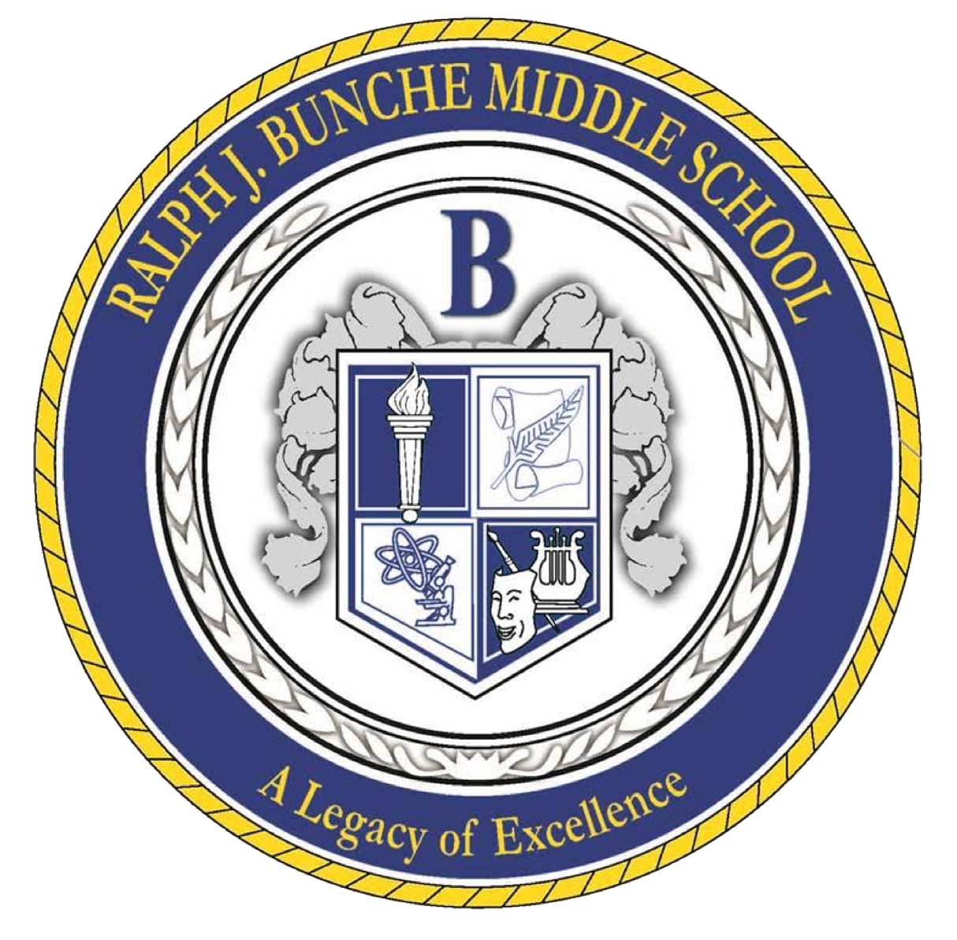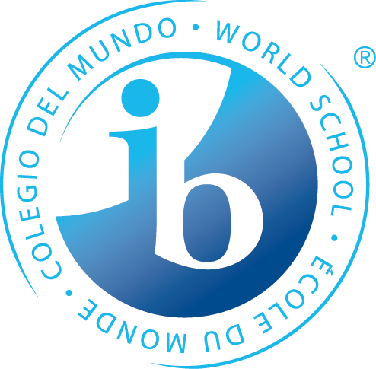

**The Bunche Mission Statement**

Through rigorous learning experiences and a challenging international education program, Ralph J Bunche will develop 21st-century lifelong learners who are competent, caring, and contributing members of a global society prepared for high school and beyond.

**Purpose**

At Ralph J. Bunche Middle School (BMS), all students can access the MYP programme. This access also comes with responsibilities, and this document outlines the specifics. A committee of teachers, leadership staff, and administrators from BMS’ International Baccalaureate Middle Years Programme (IB MYP) developed this document to outline the critical components of our Admission Policy.

**Zoning and Feeder Schools**

# Ralph J. Bunche Middle School aims to provide a quality international education to as many students as possible. All students from our feeder schools (Fickett, Deerwood, Continental Colony, and LO. Kimberly) are automatically welcome at Bunche Middle as they transition from the PYP programs into the MYP programs. We also welcome all new students into our community.

**Admission Requirements**

"At Ralph J. Bunche Middle School, we embrace students from all backgrounds and believe that the MYP program offers valuable benefits to everyone. For this reason, we maintain no admissions requirements and encourage all students to seize this opportunity. Our commitment is to deliver a rigorous education that empowers students to become lifelong learners who are compassionate, well-rounded, and ready to positively impact the world. We eagerly anticipate your joining our community, where you will engage in learning through inquiry and take an active role in your education both inside and outside the classroom."

**Admission Rights and Responsibilities**

| **Rights** | **Responsibilities** |
| --- | --- |
| **Students**   * An MYP inquiry-based quality education. * Be treated with dignity and respect in the admission process * Be included in the admission process * Have continuity in your learning for the Three years of your MYP programme at Ralph J. Bunche Middle. | **Our School Community**   * Understand that every child has a fundamental right to education   **The School**   * Ensures access to IB education to a large number of possible students * Ensure the programme is available to the whole school community.   **School Leadership (From the Principal, the entire admin team to the Instructional Lead team to the Support Team)**   * Ensures that all team members understand what equity means to our growing community. * Ensures that all of our students have access to an IB education * Promotes learning diversity as a valued and rich resource for building communities.   **Teachers**   * Welcome and include new students in their classroom learning communities. |
| **Families**   * Receive timely responses * Receive all the guidelines and necessary information * Are treated with dignity and respect during the admission process | **Families**   * Equip the school with all required information * Update contact information |
| **The School**   * Receives complete and accurate information about the student from families. (Accolades as well as behavior folders) | **School Leadership**   * Communicates with families promptly and provides opportunities for dialogue. * Communicate and provide all guidelines and information about processes. * Listen to all learners' voices, parents, caregivers, support staff, and non-teaching staff. |

**Bibliography**

International Baccalaureate Organization, 2011.

International Baccalaureate Organization. *MYP: From Principles into Practice*. Cardiff:

International Baccalaureate Organization. 2014/2015.

International Baccalaureate Organization. *Programme Standards and Practices*.

Cardiff: International Baccalaureate Organization, April 2022.

Language and literature guide. (2020). International Baccalaureate Organization.